Assassination of Franz Ferdinand
28th June 1914

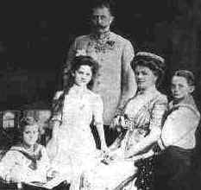 |  | Franz Ferdinand, aged 51, was heir to the Austro-Hungarian Empire. He was married to Sophie Chotek von Chotvoka and had three children. Franz Ferdinand was, however, very unpopular because he had made it clear that once he became Emperor he would make changes.
This map, of the Austro-Hungarian Empire in 1914, shows that Bosnia/Herzegovnia was controlled by Austria. Austria had annexed (taken by force) Bosnia in 1908, a move that was not popular with the Bosnian people. |  |  |  | 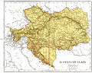
Franz Ferdinand decided to visit Sarajevo, the capital of Bosnia and Herzegovnia, to make an inspection of the Austro-Hungarian troops there. The inspection was scheduled for 28th June 1914. It was planned that Franz Ferdinand and his wife Sophie would be met at the station and taken by car to the City Hall where they would have lunch before going to inspect the troops.

A Serbian terrorist group, called The Black Hand, had decided that the Archduke should be assassinated and the planned visit provided the ideal opportunity. Seven young men who had been trained in bomb throwing and marksmanship were stationed along the route that Franz Ferdinand's car would follow from the City Hall to the inspection.

The first two terrorists were unable to throw their grenades because the streets were too crowded and the car was travelling quite fast. The third terrorist, a young man called Cabrinovic, threw a grenade which exploded under the car following that of the Archduke. Although the Archduke and his wife were unhurt, some of his attendants were injured and had to be taken to hospital.
 | After lunch at the City Hall, Franz Ferdinand insisted on visiting the injured attendants in hospital. However, on the way to the hospital the driver took a wrong turn. Realising his mistake he stopped the car and began to reverse. Another terrorist, named Gavrilo Princip, stepped forward and fired two shots. The first hit the pregnant Sophia in the stomach, she died almost instantly. The second shot hit the Archduke in the neck. He died a short while later.
The bodies of Franz Ferdinand and his wife Sophie. |  | 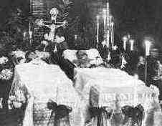 | Gavrilo Princip was not executed because he was under 20 years, but was sentenced to twenty years in prison. He died of TB in 1918.
Students will produce a newspaper front page on the death of Franz Ferdinand. The article should explain how the actions of the archduke led to his assassination – this will include details of the assassination. Students should also consider alternative courses of action the archduke could have taken as well as other steps that could have been taken to avoid the assassination. Work should be well organized and structured into paragraphs.

Causes of World War One
Although it was the assassination of the Austrian archduke, Franz Ferdinand that led to the outbreak of world war one in August 1914, the actual causes of the war were more complicated and not confined to a single cause.

Alliances
An alliance is an agreement made between two or more countries to give each other help if it is needed. When an alliance is signed, those countries become known as Allies. A number of alliances had been signed by countries between the years 1879 and 1914. These were important because they meant that some countries had no option but to declare war if one of their allies declared war first.

Imperialism  Imperialism is when a country takes over new lands or countries and makes them subject to their rule. By 1900 the British Empire extended over five continents and France had control of large areas of Africa. The amount of lands 'owned' by Britain and France increased the rivalry with Germany who had entered the scramble to acquire colonies late and only had small areas of Africa. |  | 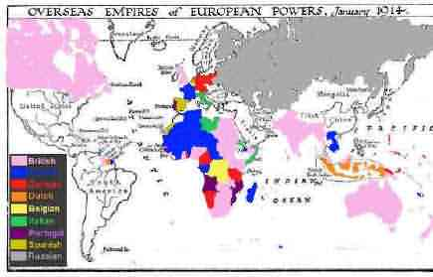Pink = British Blue = French  Red = German
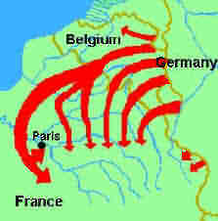 | Militarism  Militarism means that the army and military forces are given a high profile by the government. The growing European divide had led to an arms race between the main countries. The armies of both France and Germany had more than doubled between 1870 and 1914 and there was fierce competition between Britain and Germany for mastery of the seas. The British had introduced the 'Dreadnought', an effective battleship, in 1906. The Germans soon followed suit introducing their own battleships. The German, Von Schlieffen also drew up a plan of action that involved attacking France through Belgium if Russia made an attack on Germany.

Nationalism
Nationalism means being a strong supporter of the rights and interests of one's country. The Congress of Vienna, held after the Napoleonic wars left both Germany and Italy as divided states. It was nationalism the re-unification of Italy in 1861 and Germany in 1871. France was angry because the settlement at the end of the Franco-Prussian war had given Alsace-Lorraine to Germany. Large areas of both Austria-Hungary and Serbia were home to differing nationalist groups, all of whom wanted freedom from the states in which they lived.

Crises
The Moroccan Crisis - In 1904 Morocco had been given to France by Britain, but the Moroccans wanted independence and were supported by Germany. War was avoided, but in 1911, the Germans were again protesting against French possession of Morocco. Britain supported France and Germany was persuaded to back down for part of French Congo.

The Bosnian Crisis - In 1908, Austria-Hungary took over Bosnia. This angered Serbians who felt the province should be theirs. Serbia threatened Austria-Hungary with war, Russia, allied to Serbia, mobilised its forces. Germany, allied to Austria-Hungary mobilised its forces and prepared to threaten Russia. War was avoided when Russia backed down. In 1911 and 1912 there was war in the Balkans when the Balkan states drove Turkey out of the area. The states then fought each other over which area should belong to which state. Austria-Hungary intervened and forced Serbia to give up land. Tension between Serbia and Austria-Hungary was high.

Activities – Causes of WW1
1. What is meant by the term alliance?

2. Which countries were allied by the Triple Alliance?

3. Which countries were allied by the Triple Entente?

4. Why was Germany annoyed by Imperialism?

5. Which armies had increased in size between 1870 and 1914?

6. Describe the Schlieffen Plan.

7. Why were the two crises important factors

ON A SEPARATE SHEET OF PAPER:
1. Which countries were bound to each other by which alliance?

2. How did imperialism contribute towards Germany’s increasing anger with Britain and France?

3. Why was nationalism an important factor?

4. Describe the part played by Germany in increasing European militarism.

5. What links were there between the two crises and:
- Alliances
- Imperialism
- Militarism
- Nationalism

