“Enemies from Within”: Senator Joseph R. McCarthy’s Accusations of Disloyalty
Today we are engaged in a final, all-out battle between communistic atheism and Christianity. The modern champions of communism have selected this as the time, and ladies and gentlemen, the chips are down—they are truly down.
Lest there be any doubt that the time has been chosen, let us go directly to the leader of communism today—Joseph Stalin. Here is what he said—not back in 1928, not before the war, not during the war—but 2 years after the last war was ended: “To think that the Communist revolution can be carried out peacefully, within the framework of a Christian democracy, means one has either gone out of one’s mind and lost all normal understanding, or has grossly and openly repudiated the Communist revolution.” . . .
Ladies and gentlemen, can there be anyone tonight who is so blind as to say that the war is not on? Can there by anyone who fails to realize that the Communist world has said the time is now? . . . that this is the time for the show-down between the democratic Christian world and the communistic atheistic world?
Unless we face this fact, we shall pay the price that must be paid by those who wait too long.
Six years ago, . . . there was within the Soviet orbit, 180,000,000 people. Lined up on the antitotalitarian side there were in the world at that time, roughly 1,625,000,000 people. Today, only six years later, there are 800,000,000 people under the absolute domination of Soviet Russia—an increase of over 400 percent. On our side, the figure has shrunk to around 500,000,000. In other words, in less than six years, the odds have changed from 9 to 1 in our favor to 8 to 5 against us.
The reason why we find ourselves in a position of impotency is not because our only powerful potential enemy has sent men to invade our shores . . . but rather because of the traitorous actions of those who have been treated so well by this Nation. It has not been the less fortunate, or members of minority groups who have been traitorous to this Nation, but rather those who have had all the benefits that the wealthiest Nation on earth has had to offer . . . the finest homes, the finest college education and the finest jobs in government we can give.
This is glaringly true in the State Department. There the bright young men who are born with silver spoons in their mouths are the ones who have been most traitorous. . . .
I have here in my hand a list of 205 . . . a list of names that were made known to the Secretary of State as being members of the Communist Party and who nevertheless are still working and shaping policy in the State Department. . . .
As you know, very recently the Secretary of State proclaimed his loyalty to a man guilty of what has always been considered as the most abominable of all crimes—being a traitor to the people who gave him a position of great trust—high treason. . . .
He has lighted the spark which is resulting in a moral uprising and will end only when the whole sorry mess of twisted, warped thinkers are swept from the national scene so that we may have a new birth of honesty and decency in government.

http://historymatters.gmu.edu/d/6456

The source discussed and analyzed below contains an excerpt from Nikita Khrushchev’s March 1, 1961 speech to the Soviet Union. The excerpt was broadcasted on the home service radio channel and published in the daily report from the foreign radio broadcasts on USSR National Affairs. Khrushchev served as the General Secretary of the Communist Party of the Soviet Union from 1953 to 1964.
The main purpose of Khrushchev’s speech was to correlate scientific achievement to the security, strength, and power of the Soviet Union. Specifically, Khrushchev does this in two ways: 1) by highlighting the protection science has provided against America and 2) by using the space race as an example of how the Soviet Union can conquer any opponent or obstacle.
Khrushchev begins by illustrating the serious threat America poses to the Soviet Union. He refers to Americans as “imperialists” who created an atomic policy bent on “intimidating” the Soviet Union. Khrushchev’s main example of such intimidation is the American attempt to surround the Soviet Union with military bases. However, according to Khrushchev the Soviet Union has already successfully created the atomic bomb, hydrogen bomb, and inter-continental ballistic missiles. More so, through the production of these weapons, Khrushchev reassures the people that the Soviet Union is more than capable of protecting itself.
Throughout the speech, Khrushchev emphasizes the brilliance of the USSR scientists. This is highlighted when Khrushchev makes the false claim that the Soviet Union beat the United States to inventing the hydrogen bomb. Historically, the United States’ first test of the hydrogen bomb, named Ivy Mike, was conducted on November 1, 1952, while the Soviet Union did not produce its first true hydrogen bomb until November 22, 1955. In addition, when speaking about the production of the atomic bomb, Khrushchev makes it seem as if their scientists figured out how to develop the bomb all on their own. Nowhere in his speech does Khrushchev mention the role espionage played in building the bomb, such as that conducted by Klaus Fuchs, a USSR spy who worked on the Manhattan Project in Los Alamos. Instead Khrushchev maintains how USSR scientists are not only able to keep up with the United States scientifically, but can out-produce them.
Finally, Khrushchev ends his speech by describing the scientific achievements of sending the first rocket to space and the first rocket to Venus. It is important to note, he uses these achievements as examples to show the great power of the Soviet Union. In Khrushchev’s eyes because the Soviet Union has out-produced the United States in weapons and space technology, the Soviet Union has in essence defeated the United States. Furthermore, with capitalism no longer a concern, the Soviet Union is free to pursue its goal of communism. In conclusion, the overall significance of this speech is that it lets us peak into the mindset of the Soviet Union during the Cold War. Moreover, we learn that within this mindset of the Soviet Union, out performing the United States in science was viewed as the key to beating capitalism entirely

https://histsci122v.wordpress.com/2013/09/27/primary-source-speech-by-nikita-khrushchev-1-march-1961/

Transcript of Speech by Nikita Khrushchev, 1 March 1961

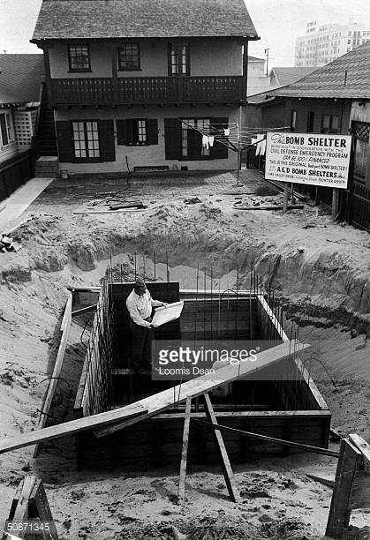

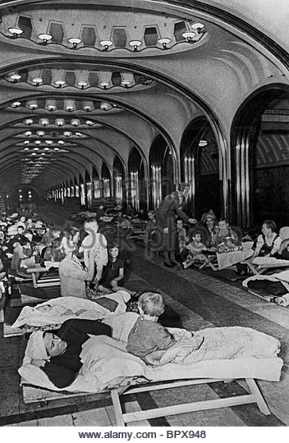
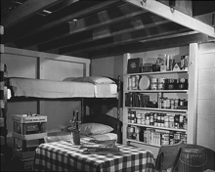

Dwight D. Eisenhower: 6-Speacial Message to the Congress on the Situation in the Middle East

These things stress the immense importance of the Middle East. If the nations of that area should lose their independence, if they were dominated by alien forces hostile to freedom, that would be both a tragedy for the area and for many other free nations whose economic life would be subject to near strangulation. Western Europe would be endangered just as though there had been no Marshall Plan, no North Atlantic Treaty Organization. The free nations of Asia and Africa, too, would be placed in serious jeopardy. And the countries of the Middle East would lose the markets upon which their economies depend. All this would have the most adverse, if not disastrous, effect upon our own nation's economic life and political prospects.
Then there are other factors which transcend the material. The Middle East is the birthplace of three great religions-Moslem, Christian and Hebrew. Mecca and Jerusalem are more than places on the map. They symbolize religions which teach that the spirit has supremacy over matter and that the individual has a dignity and rights of which no despotic government can rightfully deprive him. It would be intolerable if the holy places of the Middle East should be subjected to a rule that glorifies atheistic materialism.
International Communism, of course, seeks to mask its purposes of domination by expressions of good will and by superficially attractive offers of political, economic and military aid. But any free nation, which is the subject of Soviet enticement, ought, in elementary wisdom, to look behind the mask.
Remember Estonia, Latvia and Lithuania! In 1939 the Soviet Union entered into mutual assistance pacts with these then dependent countries; and the Soviet Foreign Minister, addressing the Extraordinary Fifth Session of the Supreme Soviet in October 1939, solemnly and publicly declared that "we stand for the scrupulous and punctilious observance of the pacts on the basis of complete reciprocity, and we declare that all the nonsensical talk about the Sovietization of the Baltic countries is only to the interest of our common enemies and of all anti-Soviet provocateurs." Yet in 1940, Estonia, Latvia and Lithuania were forcibly incorporated into the Soviet Union.
Soviet control of the satellite nations of Eastern Europe has been forcibly maintained in spite of solemn promises of a contrary intent, made during World War II.
Stalin's death brought hope that this pattern would change. And we read the pledge of the Warsaw Treaty of 1955 that the Soviet Union would follow in satellite countries "the principles of mutual respect for their independence and sovereignty and noninterference in domestic affairs." But we have just seen the subjugation of Hungary by naked armed force. In the aftermath of this Hungarian tragedy, world respect for and belief in Soviet promises have sunk to a new low. International Communism needs and seeks a recognizable success.
Thus, we have these simple and indisputable facts:
1. The Middle East, which has always been coveted by Russia, would today be prized more than ever by International Communism.
2. The Soviet rulers continue to show that they do not scruple to use any means to gain their ends.
3. The free nations of the Mid East need, and for the most part want, added strength to assure their continued independence.

http://www.presidency.ucsb.edu/ws/?pid=11007

Castro 4 June Speech Moscow TASS in English to Europe 1109 5 June 1963

After stressing that primary attention is devoted in the Soviet Union to the solution of economic tasks, Fidel Castro pointed out at the same time, that, unfortunately, the Cuban revolutionaries still show little concern for the development of economy. In the USSR, he said, everybody, and the Communist Party above all, shows concern for economic development. Fidel Castro described in detail the biggest construction projects he had seen in the Soviet Union, specifically the Siberian hydropower stations, and also spoke about the development of Soviet agriculture. He repeatedly emphasized the necessity for using Soviet experience in solving internal tasks of socialist construction in Cuba.

Turning to Soviet-Cuban relations, Fidel Castro said that the Cuban delegation was fully satisfied with the results of its visit to the USSR. It was a very useful visit, he stressed. We have gained much experience.

After noting that the prices of sugar bought by the Soviet Union from Cuba were raised at the initiative of the Soviet Union, Fidel Castro said: This is a great help to our national economy. The Cuban Prime Minister also
pointed out that the Soviet people expressed by their deeds their love for and solidarity with Cuba.

During a conversation with N. S. Khrushchev, Fidel Castro went on, we discussed most diverse problems of the Cuban economy. Khrushchev, who has vast experience in agriculture, displayed a keen interest in the
development of a machine to harvest sugar cane that would solve the main problem in increasing the output of sugar.

Characterizing Cuba's international situation, Fidel Castro noted that the danger of U.S. aggression against Cuba has not been completely removed. It will exist as long as imperialism exists. But the balance of power, he said, has changed and this danger diminishes with the growing might of the socialist countries. Imperialists know full well what aggression against Cuba might spell for them.

Fidel Castro expressed readiness to normalize relations with the United States by discussing all outstanding issues.

The leader of the Cuban revolution spoke much about his impressions of his meetings with Khrushchev. We extensively discussed different problems, he said. This is an exceptionally intelligent, energetic, and kind man.
Comrade Khrushchev is a careful and good organizer. He has tremendous experience in the revolutionary struggle and deep theoretical knowledge enriched by practice. He has traversed a long way from a miner to the leader of the proletarian state.

Khrushchev, Fidel Castro said, shows deep concern for internal and international problems, particularly for the question of the unity of the socialist camp. This is a man who works much and gives thought to the future. He is deeply concerned for the problems of protecting peace and the struggle against arms race and against a thermonuclear war. Khrushchev, Fidel Castro declared, is a great leader and a resolute enemy of imperialism.

Fidel Castro closed his speech by stressing the need for strengthening the unity of the international communist movement through exchange of views. This, he declared, is the proper way to settle all problems. We are communists, Fidel Castro said, and our fate is bound with that of the entire communist camp. We are on the right way.

http://lanic.utexas.edu/project/castro/db/1963/19630606.html

Mr. STRIPLING: As a member of the board of directors, as president of the Screen Actors Guild, and as an active member, have you at any time observed or noted within the organization a clique of either Communists or Fascists who were attempting to exert influence or pressure on the guild?
Mr. REAGAN: Well, sir, my testimony must be very similar to that of Mr. (George) Murphy and Mr. (Robert) Montgomery. There has been a small group within the Screen Actors Guild which has consistently opposed the policy of the guild board and officers of the guild, as evidenced by the vote on various issues. That small clique referred to has been suspected of more or less following the tactics that we associate with the Communist Party.
Mr. STRIPLING: You have no knowledge yourself as to whether or not any of them are members of the Communist Party?
Mr. REAGAN: No, sir; I have no investigative force, or anything, and I do not know.
Mr. STRIPLING: Has it ever been reported to you that certain members of the guild were Communists?
Mr. REAGAN: Yes, sir; I have heard different discussions and some of them tagged as Communists. . . .
Mr. STRIPLING: Would you say that this clique has attempted to dominate the guild?
Mr. REAGAN: Well, sir, by attempting to put their own particular views on various issues, I guess in regard to that you would have to say that our side was attempting to dominate, too, because we were fighting just as hard to put over our views, in which we sincerely believed, and I think, we were proven correct by the figures—Mr. Murphy gave the figures—and those figures were always approximately the same, an average of 90 percent or better of the Screen Actors Guild voted in favor of those matters now guild policy.
Mr. STRIPLING: Mr. Reagan, there has been testimony to the effect here that numerous Communist-front organizations have been set up in Hollywood. Have you ever been solicited to join any of those organizations or any organization which you considered to be a Communist-front organization?
Mr. REAGAN: Well, sir, I have received literature from an organization called the Committee for a Far-Eastern Democratic Policy. I don’t know whether it is Communist or not. I only know that I didn’t like their views and as a result I didn’t want to have anything to do with them.
Mr. STRIPLING: Were you ever solicited to sponsor the Joint Anti-Fascist Refugee Committee?
Mr. REAGAN: No, sir; I was never solicited to do that, but I found myself misled into being a sponsor on another occasion for a function that was held under the auspices of the Joint Anti-Fascist Refugee Committee.
Mr. STRIPLING: Did you knowingly give your name as a sponsor?
Mr. REAGAN: Not knowingly. Could I explain what that occasion was?
Mr. STRIPLING: Yes sir.
Mr. REAGAN: I was called several weeks ago. There happened at the time in Hollywood to be a financial drive on to raise money to build a badly needed hospital in a certain section of town, called the All Nations Hospital. I think the purpose of the building is so obvious by the title that it has the support of most of the people of Hollywood—or, of Los Angeles, I should say. Certainly of most of the doctors, because it is very badly needed.
Testimony of Ronald Reagan http://historymatters.gmu.edu/d/6458

