Station 1

Poem 1
Poem 3
My daddy was
the hardest working man..
He was different than the light-skinned ones
sucking on a silver spoon, making him work.
Daddy worked on the fields,
the cotton patted his back, whispering in the wind
take my fruit and let it be your fruit
spread my seeds and let it grow.
nurture my roots and let me stand tall.
He said it was advice.
Daddy meant it gave him willpower
because the fruit of his labor grows me.
I am daddy's seed.
He will nurture me and one day,
I too will stand tall.
Thistles and the thorns,
cut, carve, clip, cleave,
my daddy's hard working hands.
Daddy never did say why they did.
He just told me
"No good work is bad labor.
I teach him the plant as it teaches me.
No matter how rough the job may be,
your success builds on the grip of your hand
and the pull and tug of your own resolution and resolve.”

The struggle is over
my heart is free
but take my brothers
no more from me!
Ink is drawn
great. Abe has spoken,
slavery is lost,
but sadness has awoken
Blood is spilled!
The red and the blue,
my love and liberty
are taken from me too.
Draw no more,
an unjust edge to cut
my mind is a tornado,
parading amuck.
Change is imminent!
Change is sanctuary
but never forget
those who bear arms that we carry.

Poem 2
I’ve had my share
of trials and tribulations.
No easy way out,
The white man says
But I’m almost there.
This whole town
can slow you down
but I push and plow,
pace and perspire.
And I’m almost there.
Crossing rivers,
climbing mountains,
my dreams race
as fast as hurricane winds
‘Cause I’m almost there.

Station 2
Alexander Stephens on Reconstruction April 11 1866

I think the people of the State would be unwilling do more than they have done for restoration. Restricted to limited suffrage would not be so objectionable as general or universal. But it is a matter that belongs to the State to regulate. The question of suffrage, whether universal or restricted, is one of State policy exclusively, as they believe. Individually I should not be opposed to a propose system of restricted or limited suffrage to this class our population. . . . The only view in their opinion that could possibly justify the war that was carried on by the federal government against them was the idea of the indisolubleness of the Union; that those who held the administration for the time were bound to enforce the execution of the laws and the maintenance of the integrity of the country under the Constitution. . . . They expected as soon as the confederate cause was abandoned that immediately the States would be brought back into their practical relations with the government as previously constituted. That is what they looked to. They expected that the States would immediately have their representatives in the Senate and in the House; and they expected in good faith, as loyal men, as the term is frequently used- loyal to law, order, and the Constitution-to support the government under the Constitution. . . . Towards the Constitution of the United States the great mass of our people were always as much devoted in their feelings as any people ever were towards any laws or people . they resorted to secession with a view of more securely maintaining these principles. And when they found they were not successful in their object in perfect good faith, as far as I can judge from meeting with them and conversing with them, looking to the future development of their country . . . their earnest desire and expectation was to allow the past struggle . . . to pass by and to co-operate with . . . those of all sections who earnestly desire the preservation of constitutional liberty and the perpetuation of the government in its purity. They have been . . . disappointed in this, and are . . . patiently waiting, however, and believing that when the passions of the hour have passed away this delay in representation will cease. .
My own opinion is, that these terms ought not to be offered as conditions precedent. . . . It would be best for the peace, harmony, and prosperity of the whole country that there should be an immediate restoration, an immediate bringing back of the States into their original practical relations; and let all these questions then be discussed in common council. Then the representatives from the south could be heard, and you and all could judge much better of the tone and temper of the people than you could from the opinions given by any individuals. . . .
My judgment, therefore, is very decided, that it would have been better as soon as the lamentable conflict was over, when the people of the south abandoned their cause and agreed to accept the issue, desiring as they do to resume their places for the future in the Union, and to look to the arena of reason and justice for the protection of their rights in the Union-it would have been better to have allowed that result to take place, to follow under the policy adopted by the administration, than to delay or hinder it by propositions to amend the Constitution in respect to suffrage. . . . I think the people of all the southern States would in the halls of Congress discuss these questions calmly and deliberately. and if they did not show that the views they entertained were just and proper, such as to control the judgment of the people of the other sections and States, they would quietly . yield to whatever should be constitutionally determined in common council. But I think they feel very sensitively the offer to them of propositions to accept while they are denied all voice . . . in the discussion of these propositions. I think they feel very sensitively that they are denied the right to be heard.

Station 3

Andrew Johnson: Third Inaugural Address

The Union and the Constitution are inseparable. As long as one is obeyed by all parties, the other will be preserved; and if one is destroyed, both must perish together. The destruction of the Constitution will be followed by other and still greater calamities. It was ordained not only to form a more perfect union between the States, but to "establish justice, insure domestic tranquillity, provide for the common defense, promote the general welfare, and secure the blessings of liberty to ourselves and our posterity." Nothing but implicit obedience to its requirements in all parts of the country will accomplish these great ends. Without that obedience we can look forward only to continual outrages upon individual rights, incessant breaches of the public peace, national weakness, financial dishonor, the total loss of our prosperity, the general corruption of morals, and the final extinction of popular freedom. To save our country from evils so appalling as these, we should renew our efforts again and again.
To me the process of restoration seems perfectly plain and simple. It consists merely in a faithful application of the Constitution and laws. The execution of the laws is not now obstructed or opposed by physical force. There is no military or other necessity, real or pretended, which can prevent obedience to the Constitution, either North or South. All the rights and all the obligations of States and individuals can be protected and enforced by means perfectly consistent with the fundamental law. The courts may be everywhere open, and if open their process would be unimpeded. Crimes against the United States can be prevented or punished by the proper judicial authorities in a manner entirely practicable and legal. There is therefore no reason why the Constitution should not be obeyed, unless those who exercise its powers have determined that it shall be disregarded and violated. The mere naked will of this Government, or of some one or more of its branches, is the only obstacle that can exist to a perfect union of all the States.
On this momentous question and some of the measures growing out of it I have had the misfortune to differ from Congress, and have expressed my convictions without reserve, though with becoming deference to the opinion of the legislative department. Those convictions are not only unchanged, but strengthened by subsequent events and further reflection The transcendent importance of the subject will be a sufficient excuse for calling your attention to some of the reasons which have so strongly influenced my own judgment. The hope that we may all finally concur in a mode of settlement consistent at once with our true interests and with our sworn duties to the Constitution is too natural and too just to be easily relinquished.
It is clear to my apprehension that the States lately in rebellion are still members of the National Union. When did they cease to be so? The "ordinances of secession" adopted by a portion (in most of them a very small portion) of their citizens were mere nullities. If we admit now that they were valid and effectual for the purpose intended by their authors, we sweep from under our feet the whole ground upon which we justified the war. Were those States afterwards expelled from the Union by the war? The direct contrary was averred by this Government to be its purpose, and was so understood by all those who gave their blood and treasure to aid in its prosecution. It can not be that a successful war, waged for the preservation of the Union, had the legal effect of dissolving it. The victory of the nation's arms was not the disgrace of her policy; the defeat of secession on the battlefield was not the triumph of its lawless principle. Nor could Congress, with or without the consent of the Executive, do anything which would have the effect, directly or indirectly, of separating the States from each other. To dissolve the Union is to repeal the Constitution which holds it together, and that is a power which does not belong to any department of this Government, or to all of them united.

Station 4

The Effects of Lincoln’s Death on National Affairs

Published: April 17, 1865, New York Times
Nevertheless, it is well to remember that the peculiar nature of our institutions makes it impossible that any one man should be absolutely indispensable to their preservation and successful working. Our government is of the people. They not only elect our rulers, but their spirit, their temper, their will pervade and control all the acts and all the measures of the government. Whoever dies, the people live, and the government lives also. If the Emperor NAPOLEON had been assassinated, all France would have been in revolution before twenty-four hours had passed away. President LINCOLN's death, sudden and awful as it was -- though it removes him in an instant from the most important and conspicuous position held by any living man, -- does not interrupt for an instant the grand movement of our republican government. So far from exciting revolution, it only unites the whole people, more thoroughly than ever, in a common sentiment of devotion to the country and of profound grief for the great calamity that has fallen upon it. All party rancor is hushed. Political strife has ceased. All men of all parties, feeling a common interest and a common grief, stand together in support of the nation and of the man thus suddenly charged with the execution of the people's will.
In President JOHNSON, moreover, the country has a man of courage, of sound judgment and of a patriotism which has stood the test of the most terrible trials. His sympathies are with the people, and all his action will be for their good. He will respond to their sentiments and will execute their will. Nor will he be unmindful of the fact that the general line of policy which ABRAHAM LINCOLN was carrying out, when arrested by the murderer's blow, commanded the hearty and universal approbation of the great mass of the American people. No man ever came suddenly to power with a plainer path before him than that which lies before the new President. And no one need fear for a moment that the rebellion is to gain anything by the death of President LINCOLN or by the accession to power of ANDREW JOHNSON as his successor.

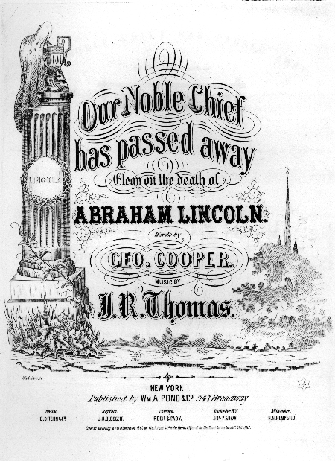

Station 5
Lincoln’s Plan
As a general rule, I abstain from reading the reports of attacks upon myself, wishing not to be provoked by that to which I can not properly offer an answer. In spite of this precaution, however, it comes to my knowledge that I am much censured for some supposed agency in setting up, and seeking to sustain, the new State government of Louisiana. In this I have done just so much as, and no more than, the public knows. In the Annual Message of Dec. 1863 and accompanying Proclamation, I presented a plan of re-construction (as the phrase goes) which, I promised, if adopted by any State, should be acceptable to, and sustained by, the Executive government of the nation. I distinctly stated that this was not the only plan which might possibly be acceptable; and I also distinctly protested that the Executive claimed no right to say when, or whether members should be admitted to seats in Congress from such States. This plan was, in advance, submitted to the then Cabinet, and distinctly approved by every member of it. One of them suggested that I should then, and in that connection, apply the Emancipation Proclamation to the theretofore excepted parts of Virginia and Louisiana; that I should drop the suggestion about apprenticeship for freed-people, and that I should omit the protest against my own power, in regard to the admission of members to Congress; but even he approved every part and parcel of the plan which has since been employed or touched by the action of Louisiana. The new constitution of Louisiana, declaring emancipation for the whole State, practically applies the Proclamation to the part previously excepted. It does not adopt apprenticeship for freed-people; and it is silent, as it could not well be otherwise, about the admission of members to Congress. So that, as it applies to Louisiana, every member of the Cabinet fully approved the plan. The message went to Congress, and I received many commendations of the plan, written and verbal; and not a single objection to it, from any professed emancipationist, came to my knowledge, until after the news reached Washington that the people of Louisiana had begun to move in accordance with it. From about July 1862, I had corresponded with different persons, supposed to be interested, seeking a reconstruction of a State government for Louisiana. When the message of 1863, with the plan before mentioned, reached New-Orleans, Gen. Banks wrote me that he was confident the people, with his military co-operation, would reconstruct, substantially on that plan. I wrote him, and some of them to try it; they tried it, and the result is known. Such only has been my agency in getting up the Louisiana government. As to sustaining it, my promise is out, as before stated. But, as bad promises are better broken than kept, I shall treat this as a bad promise, and break it, whenever I shall be convinced that keeping it is adverse to the public interest. But I have not yet been so convinced.
I have been shown a letter on this subject, supposed to be an able one, in which the writer expresses regret that my mind has not seemed to be definitely fixed on the question whether the seceding States, so called, are in the Union or out of it. It would perhaps, add astonishment to his regret, were he to learn that since I have found professed Union men endeavoring to make that question, I have purposely forborne any public expression upon it. As appears to me that question has not been, nor yet is, a practically material one, and that any discussion of it, while it thus remains practically immaterial, could have no effect other than the mischievous one of dividing our friends.
We all agree that the seceded States, so called, are out of their proper relation with the Union; and that the sole object of the government, civil and military, in regard to those States is to again get them into that proper practical relation. I believe it is not only possible, but in fact, easier to do this, without deciding, or even considering, whether these States have ever been out of the Union, than with it. Finding themselves safely at home, it would be utterly immaterial whether they had ever been abroad. Let us all join in doing the acts necessary to restoring the proper practical relations between these States and the Union; and each forever after, innocently indulge his own opinion whether, in doing the acts, he brought the States from without, into the Union, or only gave them proper assistance, they never having been out of it.
The amount of constituency, so to speak, on which the new Louisiana government rests, would be more satisfactory to all, if it contained fifty, thirty, or even twenty thousand, instead of only about twelve thousand, as it does. It is also unsatisfactory to some that the elective franchise is not given to the colored man. I would myself prefer that it were now conferred on the very intelligent, and on those who serve our cause as soldiers. Still the question is not whether the Louisiana government, as it stands, is quite all that is desirable. The question is, "Will it be wiser to take it as it is, and help to improve it; or to reject, and disperse it?" "Can Louisiana be brought into proper practical relation with the Union sooner by sustaining, or by discarding her new State government?"
Station 5
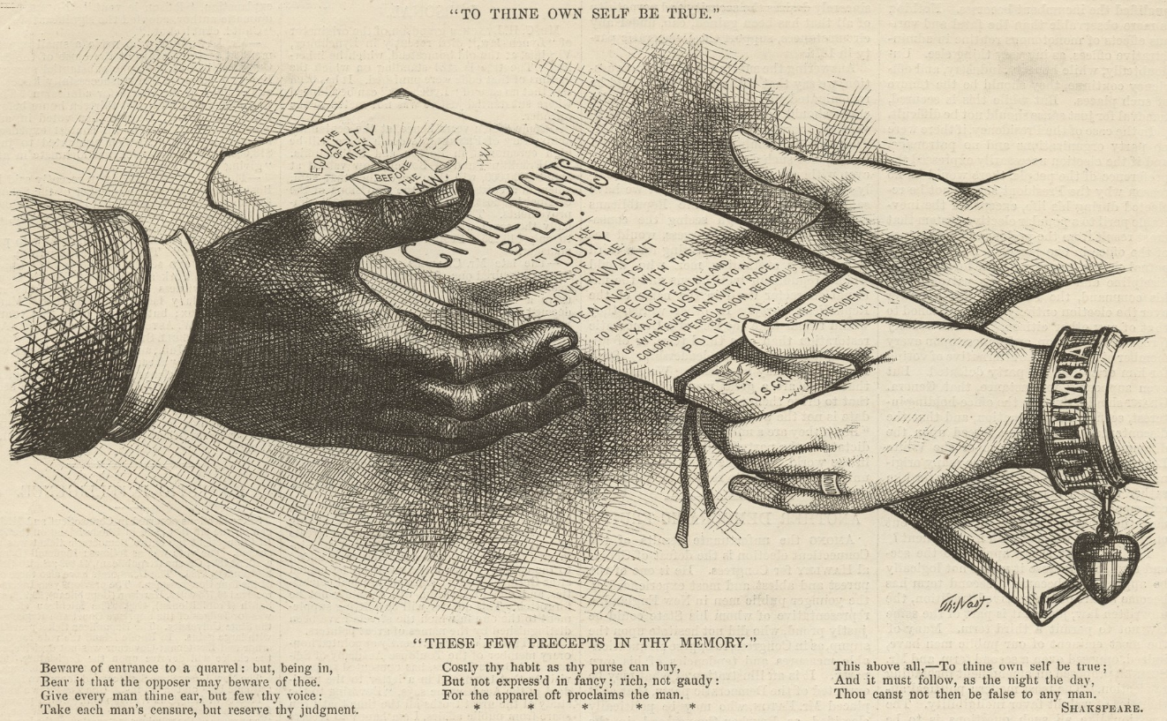
Station 5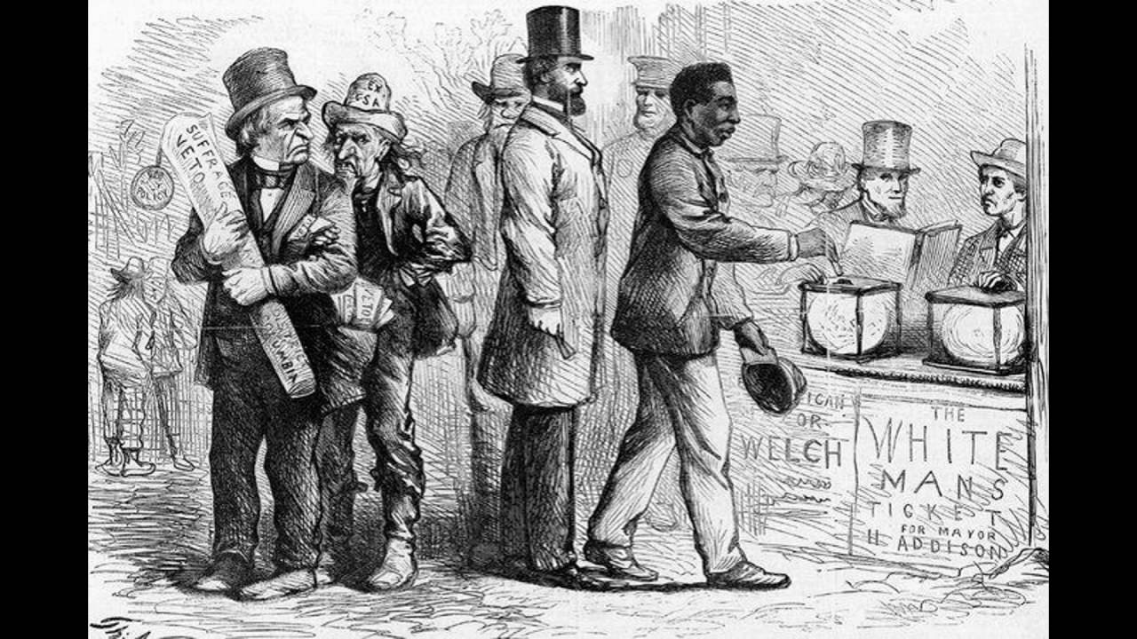
Station 7
Southern Troubles and the Prospects of Reconstruction.
New York Herald.

If the Southern States were in a condition of absolute tranquility. If the equilibrium between the two races was maintained justly, and life, property and respect for right were assured, as they are in well-governed, three facts would be without parallel. Where has it ever happened that, with' the social foundation broken up by a war which desolated every fireside, with millions of slaves, not merely made free but endowed with political rights, of whose limitations they could have but a vague comprehension; with the enfranchised class favored by the protection and countenance of the conqueror, whose generosity is so far abused by his functionaries that he becomes an oppressor where with these elements has it ever happened? It has never happened and never will happen while men are affected by the common human emotion and passions. Furthermore, we do not believe it has ever yet happened in the world tha: a people accepted the hard consequences of a disastrous defeat with even so much of heroic patience as has been shown by our people in the Southern States.
So far, therefore, from seeing any just cause for suprise in the occasional ebullitions of fury that disturb the South, the greater reason for wonder is that such events are the exception to the general condition; that the people with such widespread unanimity, have returned to their everyday life, to the occupation and pursuits of peace, and that the restoration of order and industry measured by production…In character than rum and idleness will account for in any community equally free. One might fancy from the attitude the government assume when it hears of a Southern riot and it never hears of such an event save with the characteristic exaggeration of the political adventurers with whom it is affiliated that It expected the energetic ant people of the Southern State to assume…the placid demeanor of a procession of little Sunday school saints brought up to receive the gift in each fat little hand of a nice orange and a pretty picture. But governments wisely administered consider the character of the people subject to their rule and endeavor to control them such as they are, and do not put in their place an imaginary people to be ruthlessly crushed if they are not ready to adapt themselves to some arbitrary standard of good behavior. Judged properly, it is clear a noonday that not an event has occurred in the South that we have not abundant reason to expect would occur that was not in fact prepared and made inevitable by the government and it creatures; and also not an event has occurred that would not have occurred in any Northern State in the same circumstance. Do we at the North in times of disorder control our tempers and our actions so well that we can afford to threaten military occupation to districts where popular apprehension takes the form of administering some swift justice?...
Prepare deliberately the event that will irritate and excite a people and that must provoke them to violent acts if they are human; then wait till the violence you are prepared for occur, and send your troops to occupy their cities. Is this the spirit of reconstruction that I to make the country one again? This is the plan that seems the wisest to General Grant's Attorney to the head of the national department of justice…in such a reconstruction of Louisiana as he accomplished the worst purpose that the worst of party plunderers could possibly propose to themselves. And again he lends himself to the further application of similar projects. Grant, …protests that there is no occasion to send troops into the Southern States. But the man who 'reconstructed" Louisiana, and who would, if left alone, have reconstructed Arkansas, is evidently ready to reconstruct as many other States as the wicked designs of a plundering clique may require.
Station 8

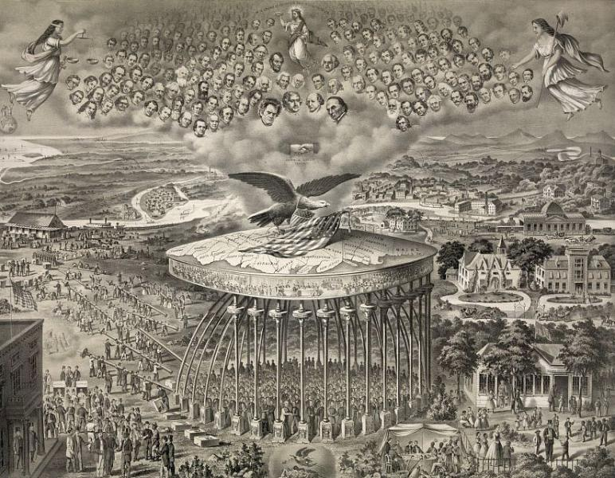

Station 8
