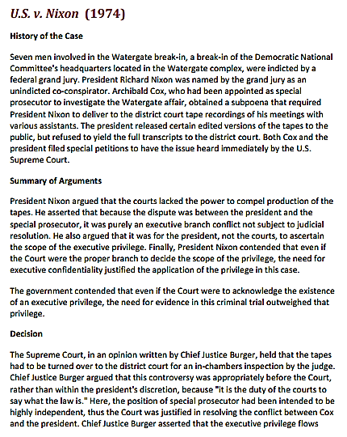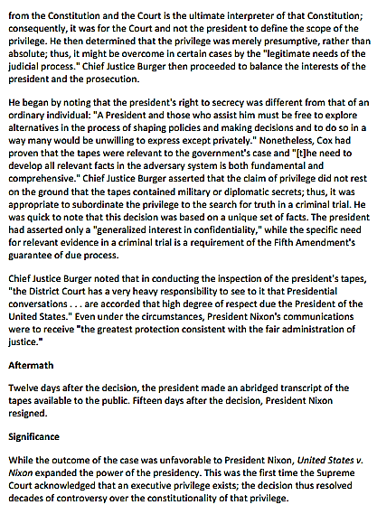

- What consequences did Nixon face for not releasing the full transcripts to the public?

- What reasoning does Nixon use for this issue not to be looked at by other branches of government?

- Do you agree with this reasoning?

- Why was Nixon’s reasoning not followed? What does this show about the national government?

- Explain the Supreme Court’s decision.

- Why does Burger say it is the court’s decision to decide the basis of executive privilege?

- What amendment is the Supreme Court basing this case on and why?

- Why is the statement “the greatest protection consistent with the fair administration of justice” so important to the case?

- What did the resignation of Nixon keep from happening and why would he resign at all?

- What were two major outcomes of the Watergate Scandal?

