[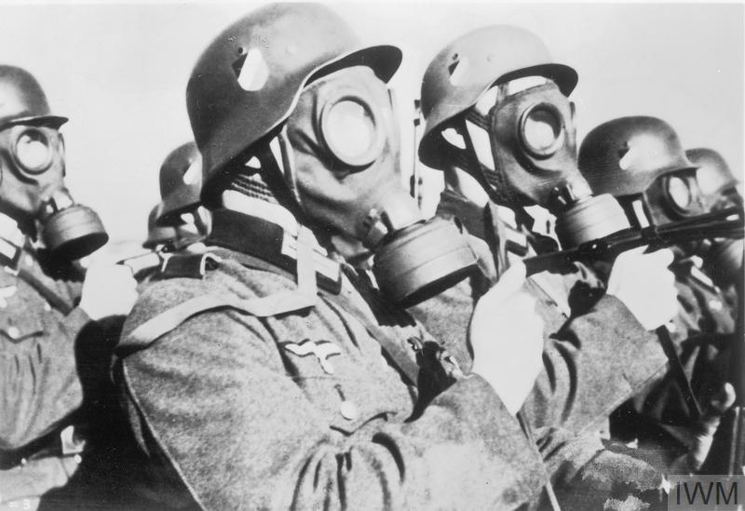](https://www.google.com/url?sa=i&rct=j&q=&esrc=s&source=images&cd=&cad=rja&uact=8&ved=0ahUKEwjNrrS44uvWAhWGMyYKHWmSBEYQjRwIBw&url=https://sites.google.com/a/aos93.org/ww1-modern-warfare-and-technology/home/gas&psig=AOvVaw1fjFMjwJhztP25HrrbKT_w&ust=1507921212698699)

[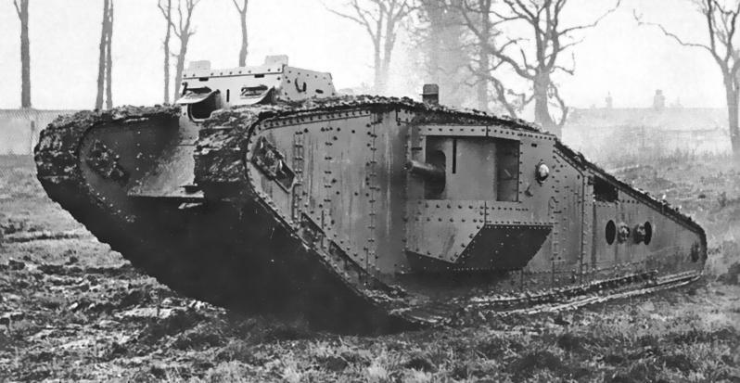](https://www.google.com/url?sa=i&rct=j&q=&esrc=s&source=images&cd=&cad=rja&uact=8&ved=0ahUKEwjwnaus5evWAhUKOiYKHWesC_UQjRwIBw&url=http://www.markedbyteachers.com/gcse/history/ww1-and-changes-in-weapons-technology.html&psig=AOvVaw1fjFMjwJhztP25HrrbKT_w&ust=1507921212698699)

[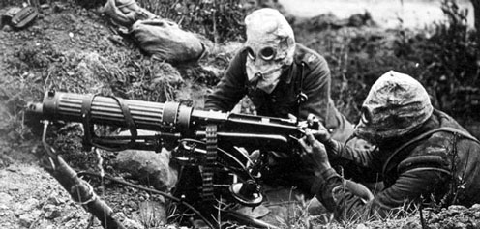](https://www.google.com/url?sa=i&rct=j&q=&esrc=s&source=images&cd=&cad=rja&uact=8&ved=0ahUKEwj8wInc5evWAhULPiYKHbVcA3kQjRwIBw&url=http://www.bbc.co.uk/guides/zs666sg&psig=AOvVaw1fjFMjwJhztP25HrrbKT_w&ust=1507921212698699)

[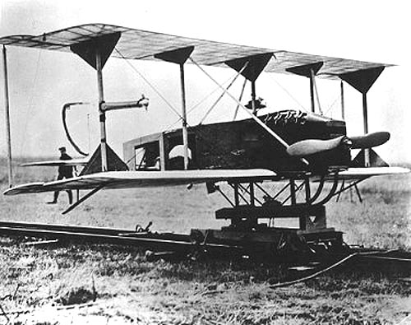](https://www.google.com/url?sa=i&rct=j&q=&esrc=s&source=images&cd=&cad=rja&uact=8&ved=0ahUKEwj6o8uA5uvWAhUMNiYKHXuWCfAQjRwIBw&url=http://mentalfloss.com/article/31882/12-technological-advancements-world-war-i&psig=AOvVaw1fjFMjwJhztP25HrrbKT_w&ust=1507921212698699)

[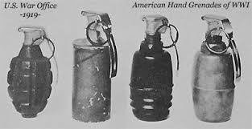](https://www.google.com/url?sa=i&rct=j&q=&esrc=s&source=images&cd=&ved=0ahUKEwiJosOj5uvWAhWM1CYKHbizCh4QjRwIBw&url=https://sites.google.com/a/aos93.org/ww1-modern-warfare-and-technology/bombs&psig=AOvVaw1fjFMjwJhztP25HrrbKT_w&ust=1507921212698699)

[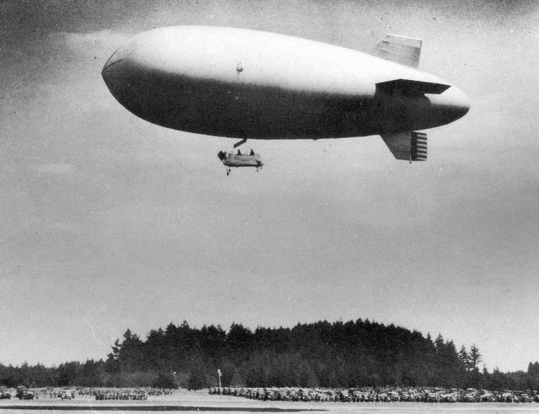](https://www.google.com/url?sa=i&rct=j&q=&esrc=s&source=images&cd=&cad=rja&uact=8&ved=0ahUKEwjuweXQ5uvWAhWRdSYKHQVODXIQjRwIBw&url=https://www.pinterest.com/gotchalk422/world-war-1/&psig=AOvVaw1fjFMjwJhztP25HrrbKT_w&ust=1507921212698699)

[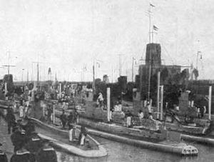](https://www.google.com/url?sa=i&rct=j&q=&esrc=s&source=images&cd=&cad=rja&uact=8&ved=0ahUKEwjGvrj05uvWAhXIRyYKHWTICQwQjRwIBw&url=http://ethw.org/World_War_I_Technology&psig=AOvVaw1fjFMjwJhztP25HrrbKT_w&ust=1507921212698699)

[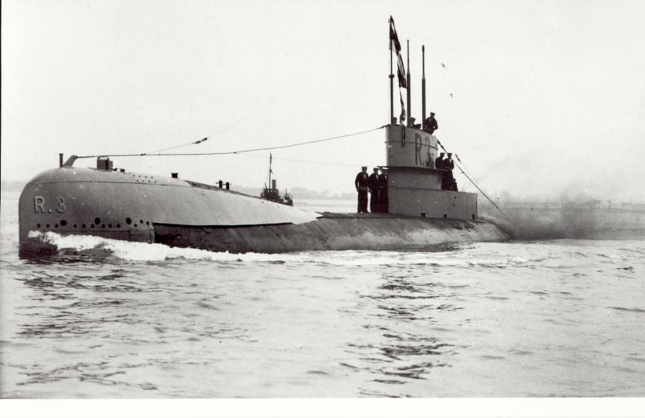](https://www.google.com/url?sa=i&rct=j&q=&esrc=s&source=images&cd=&cad=rja&uact=8&ved=0ahUKEwjG59He5-vWAhXGOyYKHSJGDuoQjRwIBw&url=http://apwhod2011.pbworks.com/w/page/40621612/WW1%20Technology&psig=AOvVaw3PdI_R-K2uM8aVbbExNexz&ust=1507922641684402)

[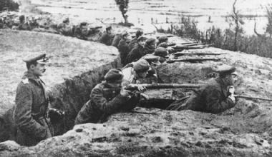](https://www.google.com/url?sa=i&rct=j&q=&esrc=s&source=images&cd=&cad=rja&uact=8&ved=0ahUKEwiFn5GB6OvWAhWBTSYKHVFBDhYQjRwIBw&url=http://www.ducksters.com/history/world_war_i/trench_warfare.php&psig=AOvVaw14BUAm7bcdzcT2vtoYYg7O&ust=1507922708125547)

[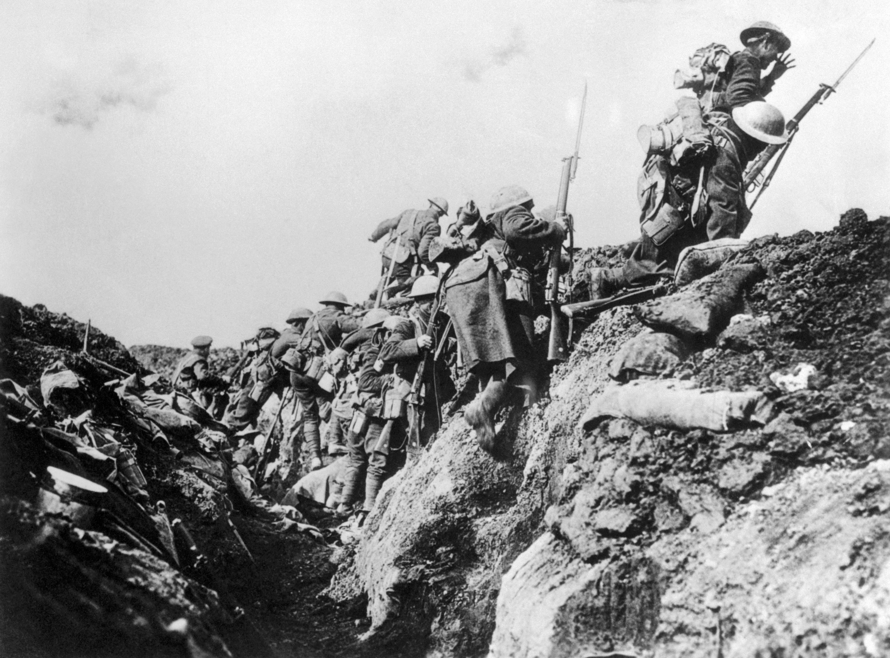](https://www.google.com/url?sa=i&rct=j&q=&esrc=s&source=images&cd=&cad=rja&uact=8&ved=0ahUKEwjI2fma6OvWAhWGNiYKHRhUACUQjRwIBw&url=http://www.history.com/topics/world-war-i/world-war-i-history/pictures/world-war-i-trench-warfare&psig=AOvVaw14BUAm7bcdzcT2vtoYYg7O&ust=1507922708125547)

[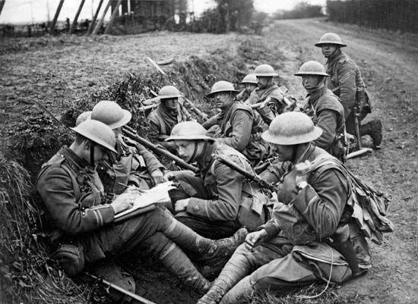](https://www.google.com/url?sa=i&rct=j&q=&esrc=s&source=images&cd=&ved=0ahUKEwiSyYHh6OvWAhWG4SYKHdsmB1UQjRwIBw&url=https://www.britannica.com/topic/trench-warfare&psig=AOvVaw14BUAm7bcdzcT2vtoYYg7O&ust=1507922708125547)

[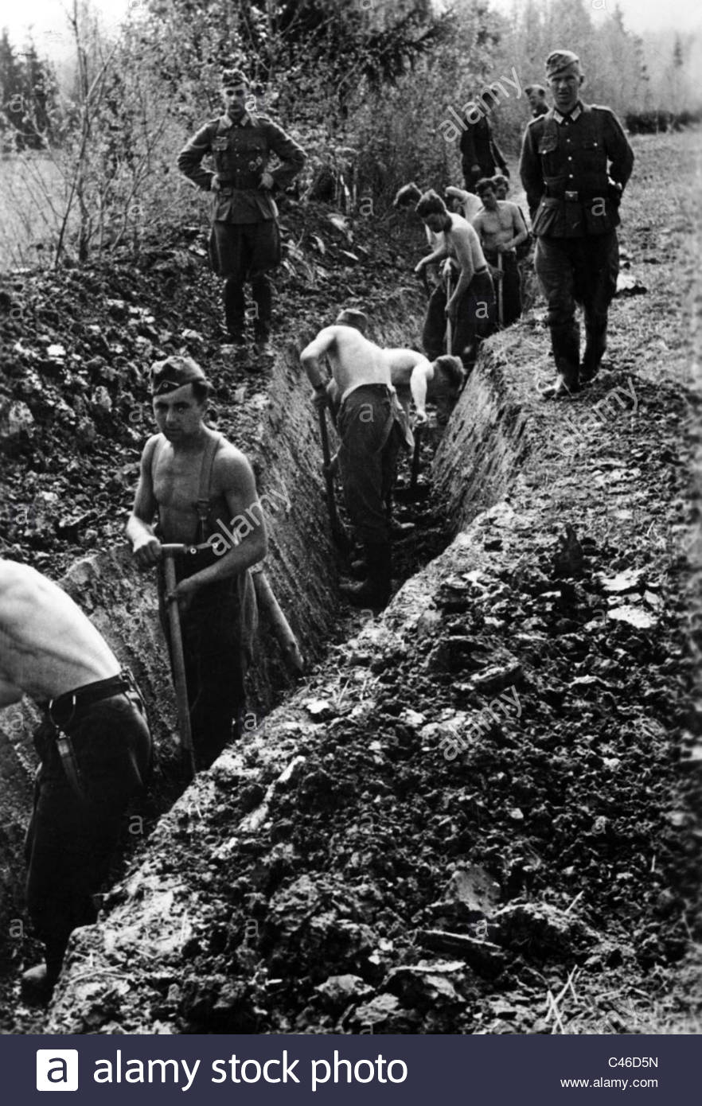](https://www.google.com/url?sa=i&rct=j&q=&esrc=s&source=images&cd=&cad=rja&uact=8&ved=0ahUKEwjB2enC6evWAhUL5iYKHY6pBeIQjRwIBw&url=http://www.alamy.com/stock-photo/trench-warfare-eastern-front.html&psig=AOvVaw14BUAm7bcdzcT2vtoYYg7O&ust=1507922708125547)

[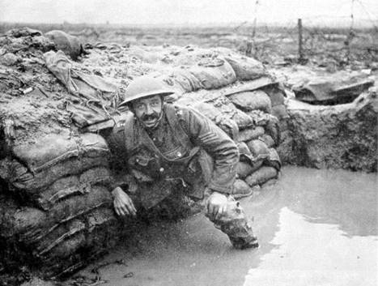](https://www.google.com/url?sa=i&rct=j&q=&esrc=s&source=images&cd=&cad=rja&uact=8&ved=0ahUKEwjzxoSO6uvWAhVJ5CYKHWX3CLAQjRwIBw&url=https://historywithatwist.wordpress.com/2014/01/22/trench-warfare-but-not-as-we-know-it/&psig=AOvVaw01JHa6CQz06NArGY0YC5gJ&ust=1507923225808525)

[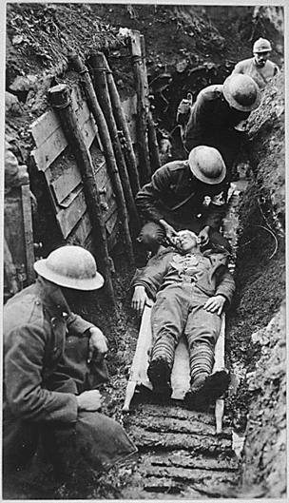](https://www.google.com/url?sa=i&rct=j&q=&esrc=s&source=images&cd=&cad=rja&uact=8&ved=0ahUKEwjAucWi6uvWAhUG5yYKHRBSAUIQjRwIBw&url=https://stratagiesandstalemateworldwari.wikispaces.com/Trench%2BWarfare&psig=AOvVaw01JHa6CQz06NArGY0YC5gJ&ust=1507923225808525)

[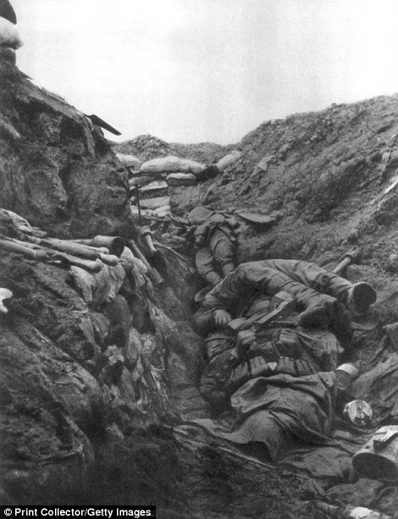](https://www.google.com/url?sa=i&rct=j&q=&esrc=s&source=images&cd=&cad=rja&uact=8&ved=0ahUKEwj87sm46uvWAhUG8CYKHatKBSIQjRwIBw&url=https://www.pinterest.com/pin/369998925616834880/&psig=AOvVaw01JHa6CQz06NArGY0YC5gJ&ust=1507923225808525)

[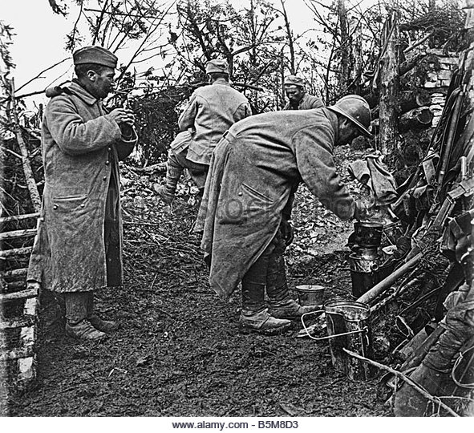](https://www.google.com/url?sa=i&rct=j&q=&esrc=s&source=images&cd=&ved=0ahUKEwiJhcDF6uvWAhVJOyYKHUVlCN0QjRwIBw&url=http://www.alamy.com/stock-photo/trench-warfare-world-war-one.html&psig=AOvVaw01JHa6CQz06NArGY0YC5gJ&ust=1507923225808525)

[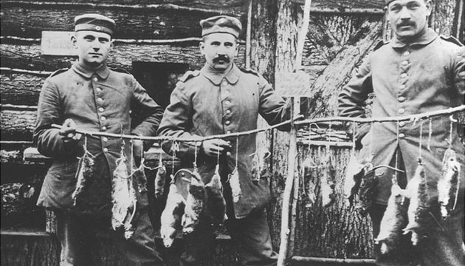](https://www.google.com/url?sa=i&rct=j&q=&esrc=s&source=images&cd=&cad=rja&uact=8&ved=0ahUKEwjhv9316uvWAhWMOCYKHUcdBEUQjRwIBw&url=http://www.bbc.co.uk/schools/0/ww1/25403863&psig=AOvVaw21HB3FssxUQ40_XYR-ZTq9&ust=1507923496946946)

**July 28, 1918**

We get up at 4 a. m. and get ready for our day’s work. After eating breakfast we march to Toronto Junction, the place we get on the light railway train, and get our morning train for the chateaux. We ride to within 200 yards of this building and get off but instead of going to our old job we march past it and cut across a large field to another railroad track which we follow for several hundred yards, finally going into a sunken bottom. I soon notice fellows asleep in holes dug back into the bank, while others are on guard. We are hailed, at a small bridge that crosses over the branch that runs through the sunken bottom by a [sentinel](http://www.learnnc.org/lp/editions/nchist-newcentury/glossary#sentinel), who says that only one man must pass over at the time and that he must stoop over as he crosses to keep from being seen by the Germans. Crossing we follow a trench that leads into another trench that is filled with English and [doughboys](http://www.learnnc.org/lp/editions/nchist-newcentury/glossary#Doughboy) from our own division, most of them laying under the ground in holes they have dug asleep. We come to another low place in the trench and again we have to stoop when crossing. Continuing on up the same trench we come to where the other section of the platoon is working and we begin working with them, throwing mud out of the trenches and putting in [duck-boards](http://www.learnnc.org/lp/editions/nchist-newcentury/glossary#duckboard) for the doughboys to walk on. Anxious to say I have seen No Man’s Land, I step on a firing base and take a look. Borrowing a pair of field glasses from an English sentinel I look over at the German trenches. Not a human being can be seen though as the Fritzies do not dare to peep over the top. Scores of British ‘planes fly about over No Man’s Land observing and occasionally diving on the German trenches pouring hundreds of machine gun bullets into them and rising again while the Germans use machine and anti-aircraft guns in an effort to shoot them down. The lieutenant warns us against looking upward while the Germans are shelling the British planes as there is danger of getting hit in the face and eyes by pieces of falling [shrapnel](http://www.learnnc.org/lp/editions/nchist-newcentury/glossary#shrapnel). But the fellows seem to pay no attention to his warning, for every time a ‘plane would draw fire they would look up at it. We do not work from 1 to 4 p. m., but are instead given that time as a rest period. We stop work for the day at 8 p. m. and start for camp. We stop at the ammunition dump where the train is supposed to meet us, and here we wait for 75 minutes, but no train shows up. In the meantime Fritz has started to shelling the roads and gradually begins shelling near this dump. Our lieutenant seeing that pretty soon Fritz will be shelling the dump gets his platoon started down the road. He was not any too soon in doing this for after we got a few hundred yards down the road shells began falling by twos and fours around this dump. We hike to camp, following the dirt road a while and then the rail track. We made a record hike, reaching camp at 11:30 p. m., sooner than we had expected to. We were all tired and hungry from the day’s work and the hike, but our cook was on the job and had a hot supper prepared for us. We did not take time to wash or put our rifles in our dugouts, but threw our rifles on the ground and lined up for “chow.” Each man received a mess kit full of mashed pototoes, beef steak and gravy, and hot cup of real coffee. Every one received a plenty and the cook was the talk of the platoon after supper.

http://www.learnnc.org/lp/editions/nchist-newcentury/5756

Dear Mother-:  
  
I think the last installment of our continued story left me as advanced billeting officer in the vicinity of Gisors. Well, I and two other boys finally got the regiment all placed and settled in a little town called Chambord. Every thing was very exciting for just then the Bosche had broken thru and were still coming and it was believed that we were going to be used to make some sort of a counter attack along with several other divisions we had seen. Hence no sooner had the division arrived than we worked for about a week on open warfare and then set out for the line. Every bit of baggage was cut down to absolutely the low limit, the officers were allowed but twenty pounds total and the men to one blanket and their regular equipment. We even had orders that the horses should be led and not ridden so that when we finally arrived everything would be fresh that mattered. Our route lay up towards Montdidier from Gisors, passing thru Beauvais, a beautiful city where later I had some splendid times. We halted for two days at Thieux and then started into line. Never will I forget the first trip I made up. The Germans had been more or less stopped and the artillery fire had become proportionately greater as it does under such circumstances. At night the whole sky seen from a distance was one continuous flickering flash of white fire, not for a few minutes but always. We left about 6:30, by we I mean myself and two guns (155 mm.)with their crews etc., planning to get to the battery as soon as the darkness would let us. Within an hour we had gotten to where our long range guns were and from then on it was a continuous performance for the ten kilometers further to our position. I had had an idea that I knew what heavy fire was but this was a revelation. The road for a good way led thru woods and what wasn’t in that woods in the way of artillery never existed. They seemed to be behind every tree and in every conceivable place. The noise was so great that to speak to any one you had to get right beside him and howl in his ear. However, it helped in that you couldn’t hear what was coming after you. There were long guns that yelped and sent a shell over that sounded like a soul from hell with its shriek.There were big, short fat ones that went floom! and sent a ton or so of metal over to the Bosche with a noise like a slow freight. And everywhere 75’s (75mm guns) going on continuously with their crack and growl. It was wonderful and somehow so inspiring that somehow you didn’t mind the danger or discomfort - for it was also raining – at all. We took up a position that looked to me like suicide itself on TOP of a hill and finally a little before daybreak got the guns in and began to add our part to the fuss.There were no organized positions. The sector was too new and ours was simply an old farm laneway behind a hedge overlooking the village of Wells Perrennes. The whole thing was about two inches deep in water when we started and every time the old boys went off a shower of liquid mud would come out from under the trail spade (the trailing portion of an artillery piece which rests on the ground for stability in firing) and cover the gun crews and executive and worse luck by then I was executing. Just about dawn too, to make things a little more pleasant Jerry started in on the town with 210’s (210 mm.guns) and we watched the houses go up in dust in spite of the rain and wondered if he was coming after us. He didn’t tho and we had breakfast of rum, bread and chocolate sitting on the powder boxes in the rain a little later.  
  
There seemed to be no limit to the amount of firing they expected of us. Five hundred (rounds) a day with a 155-mm. Howitzer is a large order for any battery but we thought that we were lucky if that was all we had to do. Usually about the time we thought that we were finished along would come a call for a barrage or a C.P.O. (order from a command post?) and when those were over it was time to begin work again.  
  
After about a week of this I suddenly received my orders to report to the Ammunition Train for duty and discovered that I had been transferred. At first I wasn’t at all well pleased as I liked the battery work very much and we just had things running nicely. I didn’t find out until later that the Am.Train was known unofficially as the suicide club but soon discovered that it might well be. Taking twenty-odd three-ton trucks loaded with shells, powder and fuses to some battery and delivering it without trouble or confusion when the Bosche are doing their own little bit of shooting took, I found, a vast amount of head work and planning. Ammunition is the one thing that can’t be held up and has got to get there and it is up to you to do it and no one but yourself cares how you do it as long as they have it to shoot. However I had rather a splendid touring car to ride about in and little or nothing to do in the daytime.  
  
About how we lived and more detail about the work I wrote you a great deal. How Reg, the Dr. and I lived and kept house in Beauvoir in an inverted style living at night and sleeping during the day.The Cantigny fight there was the only thing out of the regular fun but the work was steady, hard trench warfare. The weather throughout with the exception of the first week was perfect and we used to come home in the green and pink dawn and toast the new day in a glass of port and go to bed and sleep until noon. Thru it all tho there was the element of uncertainty for we all expected the second attack to come at any time and mostly we expected it thru us which wasn’t pleasant to contemplate.  
  
Well this is all now so good bye.  
With love  
Paul

<http://wwar1letters.blogspot.com/>

[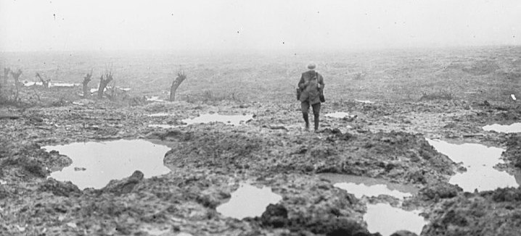](https://www.google.com/url?sa=i&rct=j&q=&esrc=s&source=images&cd=&cad=rja&uact=8&ved=0ahUKEwj3jZiEmvTWAhVHJiYKHdW5AUkQjRwIBw&url=https://www.financemagnates.com/forex/bloggers/no-mans-land-stocks-options-data/&psig=AOvVaw2Q9UvZ3F5cVIJisjM63YDd&ust=1508211021541721)

[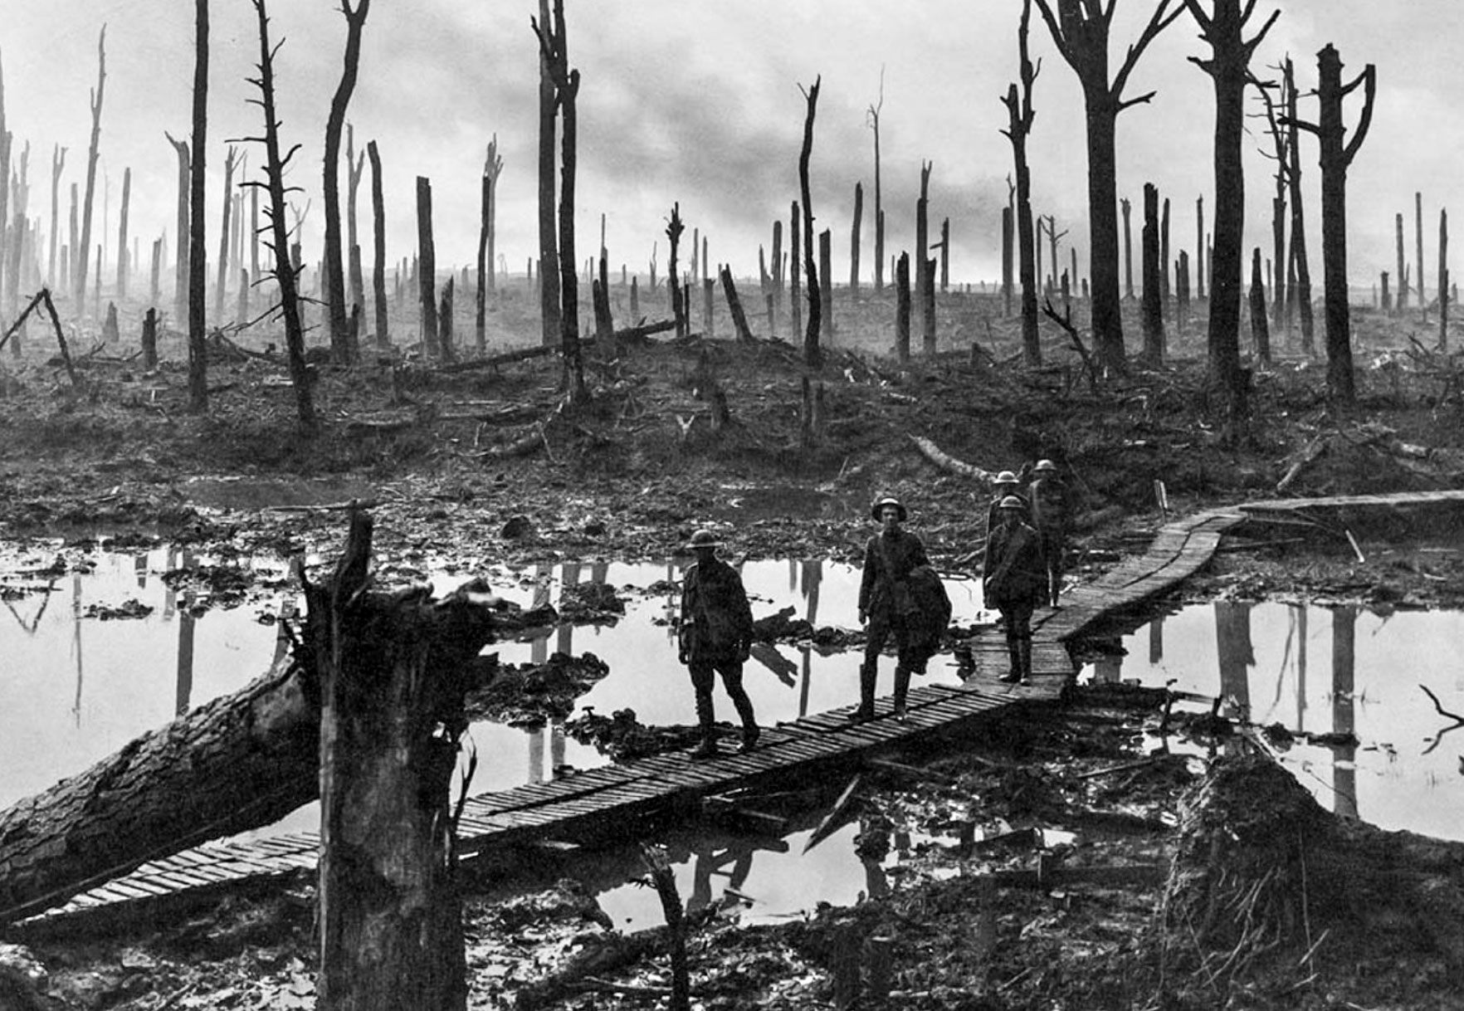](https://www.google.com/url?sa=i&rct=j&q=&esrc=s&source=images&cd=&cad=rja&uact=8&ved=0ahUKEwjY5ZCamvTWAhVISSYKHb9zBxAQjRwIBw&url=http://westwaterarts.com/repertoire/nomansland/&psig=AOvVaw2Q9UvZ3F5cVIJisjM63YDd&ust=1508211021541721)

[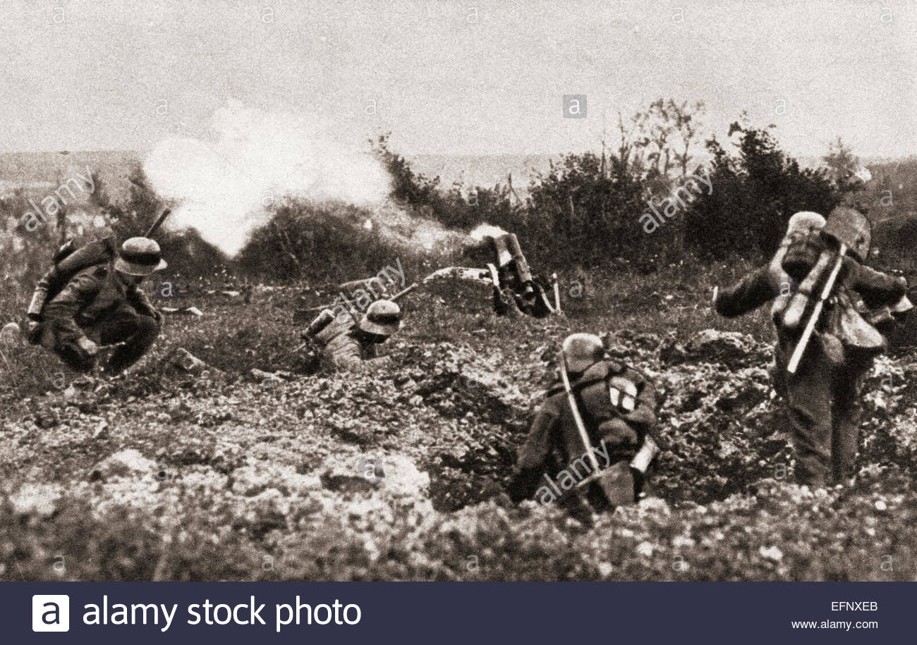](https://www.google.com/url?sa=i&rct=j&q=&esrc=s&source=images&cd=&ved=0ahUKEwjzqfrCm_TWAhUH0SYKHcr7DUcQjRwIBw&url=http://www.alamy.com/stock-photo/no-mans-land.html&psig=AOvVaw2Q9UvZ3F5cVIJisjM63YDd&ust=1508211021541721)

[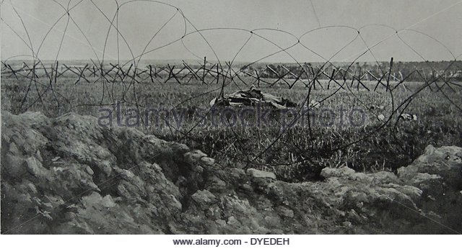](https://www.google.com/url?sa=i&rct=j&q=&esrc=s&source=images&cd=&cad=rja&uact=8&ved=0ahUKEwjGz4X2m_TWAhUJ6SYKHVhECJgQjRwIBw&url=http://www.alamy.com/stock-photo/world-war-no-mans-land.html&psig=AOvVaw0jmzXIFleGpoyXGnf01lZZ&ust=1508211520365948)

[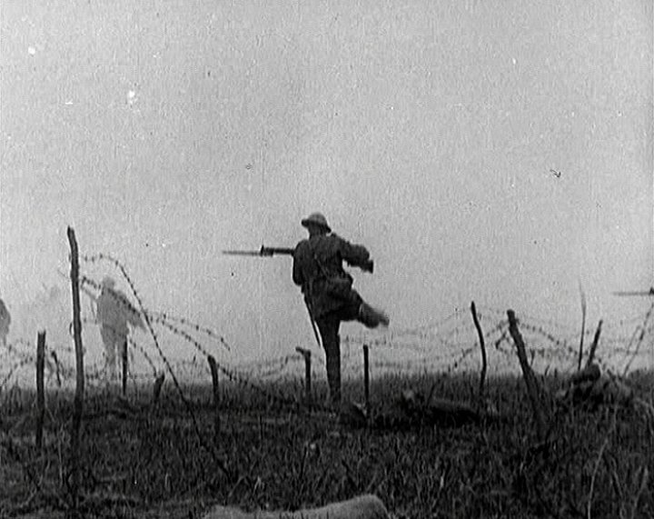](https://www.google.com/url?sa=i&rct=j&q=&esrc=s&source=images&cd=&ved=0ahUKEwjQ9OeJnPTWAhWKOyYKHaD7CIcQjRwIBw&url=https://www.emaze.com/@ACZILOFR&psig=AOvVaw0jmzXIFleGpoyXGnf01lZZ&ust=1508211520365948)

Transcript:

Nov. 1st 1918   
My Dear Mr. Brimley:   
You will probably think that I am a long time getting back to the front, but the [illegible] here is the boss and won't let me go, but promised this morning that I could go in about ten days. My wound is all healed and with the exception of a very little stiffness I am as good as ever. There is so much talk of peace I want to get back and have another try at Fritz before the finish. I think I have pretty well evened the score with him but I want to give him some more for good measure. Fritz can fight like the very devil when he is under cover and has the most men, but can't stand the Yankee steel and these Yankees, white and black sure love to use their bayonet whenever they can get near enough to him. I am in the southern part of France in the town of Vichy and quartered in one of the best hotels in the town. There are about one hundred officers at the hotel and I the only colored one so you know I am lonesome. I was as hungry as a dog the first night that I was here but walking in the dinning room seeing about one hundred white officer and no colored officers I lost my appetite - but it came back by morning and has stayed with since. I am treated fine by all the officers but most of them say I am a damn fool for wanting to get back to the front. I met Mr Thos. F Ryan's son he is a Sgt. in the Medical Corps he is sure one fine man, and is crazy to go to the front but the Col. won't let him. I wish you would send me Mr Garland Jones, and Bob's address so if any time I am near their outfit I can look them up. I see lots of people from the state but none from Raleigh but prehaps [sic] I will have luck enough to see some one before I come [crossed out in MS: go] back to the good old U.S.A. There is no news except Fritz is catching the very devil. My best regards to Mrs Brimley, Mr & Mrs Adickes [?] and all friends

Yours very respectfully   
James W Alston



[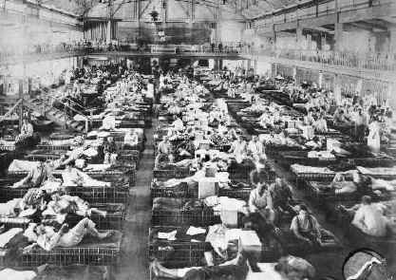](https://www.google.com/url?sa=i&rct=j&q=&esrc=s&source=images&cd=&cad=rja&uact=8&ved=0ahUKEwjS3sb3o_TWAhVKySYKHSVODnEQjRwIBw&url=https://anzacday.org.au/australian-ww1-hospitals&psig=AOvVaw1GRl2MK0wM1YNqsDtg9pDV&ust=1508213679732746)

[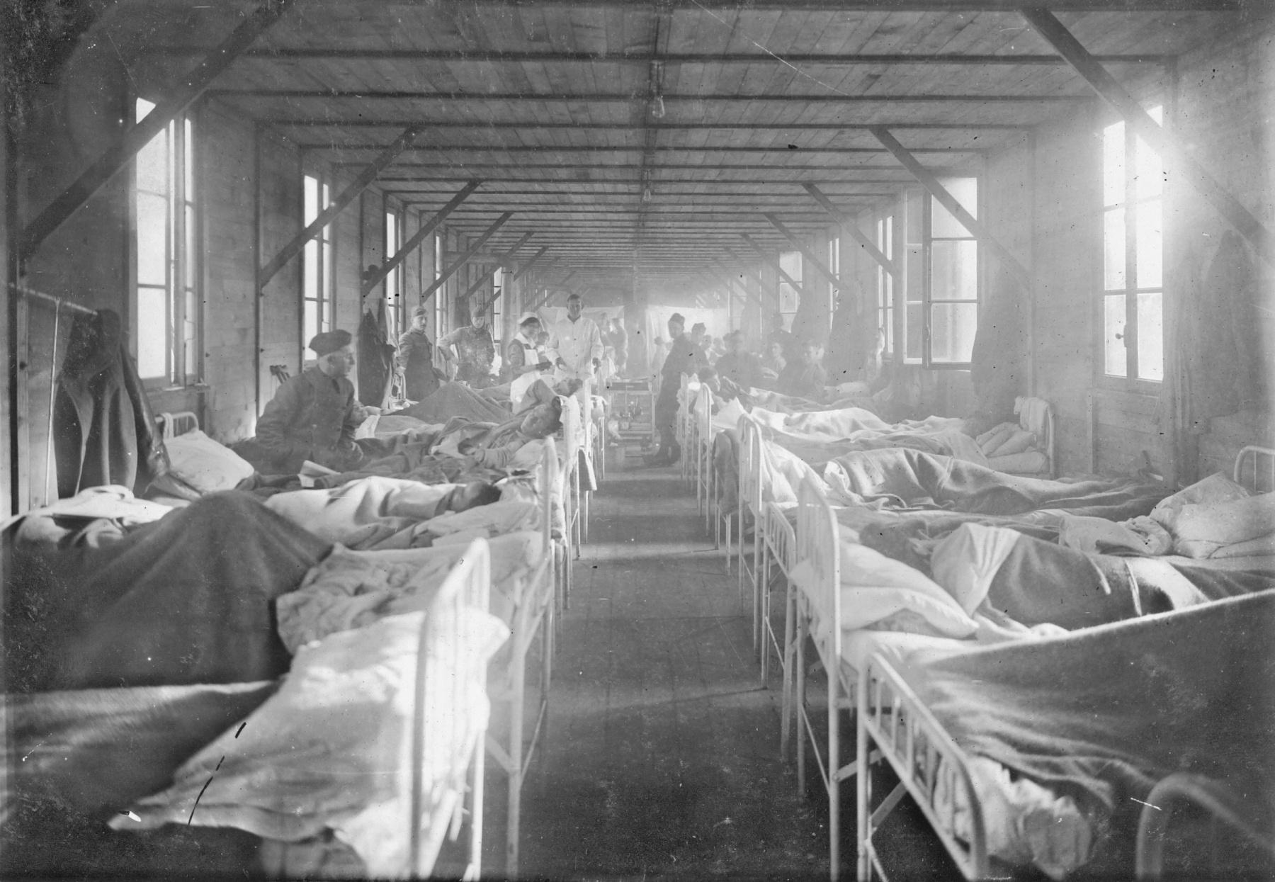](https://www.google.com/url?sa=i&rct=j&q=&esrc=s&source=images&cd=&cad=rja&uact=8&ved=0ahUKEwi1u7CXpPTWAhWGQCYKHVCWA4wQjRwIBw&url=https://www.kshs.org/kansapedia/nurse-s-uniform/10377&psig=AOvVaw1GRl2MK0wM1YNqsDtg9pDV&ust=1508213679732746)

[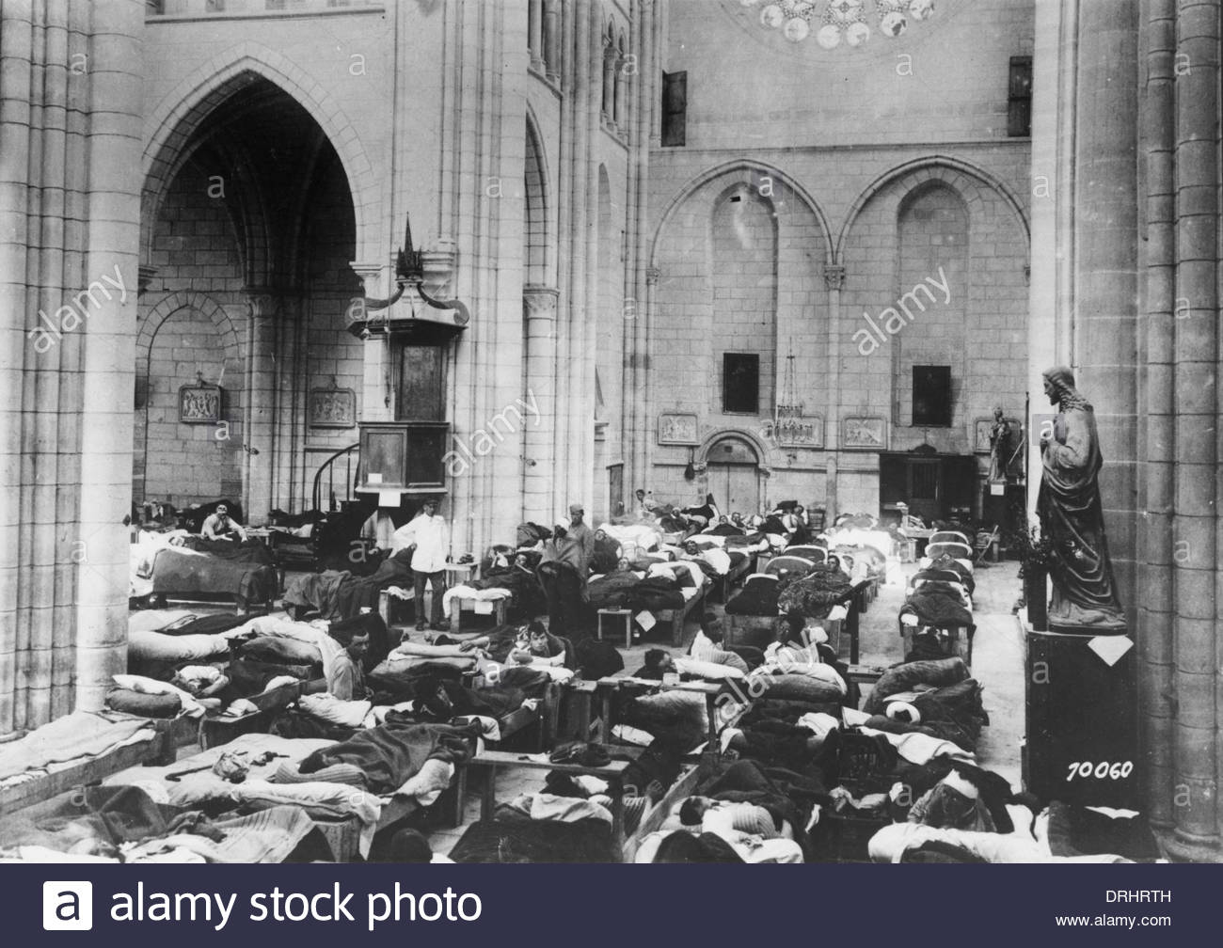](https://www.google.com/url?sa=i&rct=j&q=&esrc=s&source=images&cd=&cad=rja&uact=8&ved=0ahUKEwiH7JWvpPTWAhUQxCYKHXdNBpIQjRwIBw&url=http://www.alamy.com/stock-photo/ww1-hospital.html?blackwhite%3D1&psig=AOvVaw1GRl2MK0wM1YNqsDtg9pDV&ust=1508213679732746)

[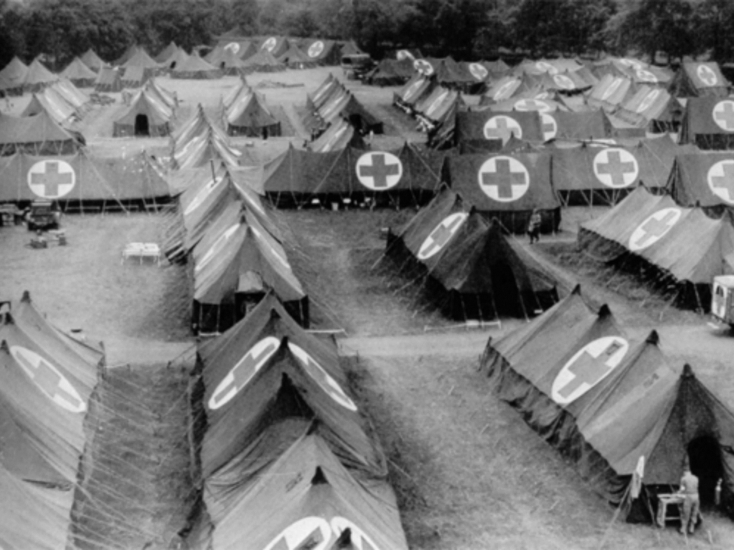](https://www.google.com/url?sa=i&rct=j&q=&esrc=s&source=images&cd=&cad=rja&uact=8&ved=0ahUKEwiOzNvUpPTWAhXDyyYKHQ_5CMsQjRwIBw&url=https://simple.wikipedia.org/wiki/Field_hospital&psig=AOvVaw0uYFRh7wka82M4YfT5kTIq&ust=1508213870644314)

[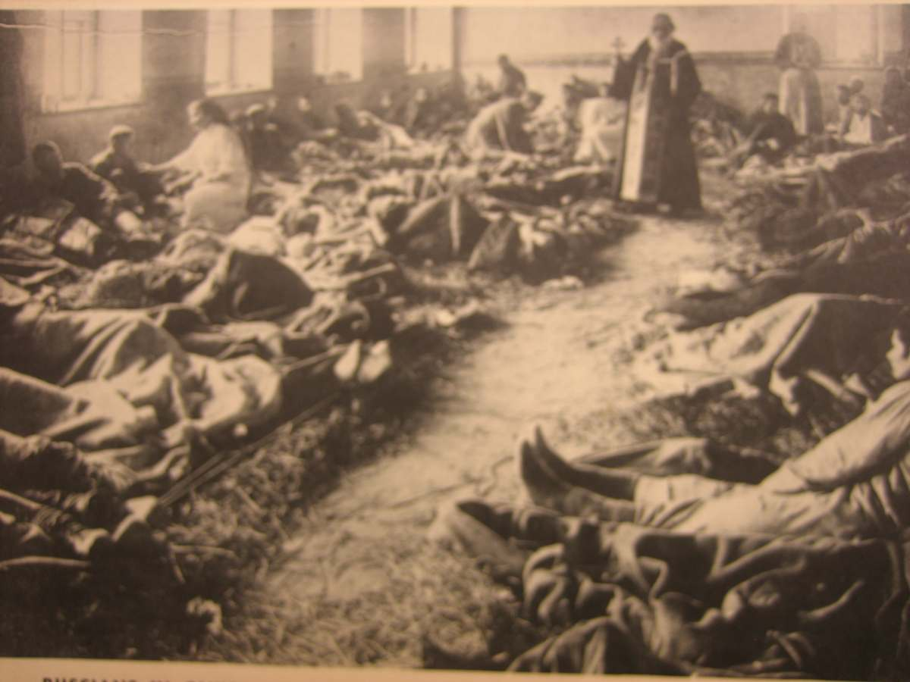](https://www.google.com/url?sa=i&rct=j&q=&esrc=s&source=images&cd=&cad=rja&uact=8&ved=0ahUKEwiorffrpPTWAhWBaSYKHTeoBHEQjRwIBw&url=https://www.vetfriends.com/MilitaryPics/large.cfm?picture%3D7391&psig=AOvVaw0uYFRh7wka82M4YfT5kTIq&ust=1508213870644314)

[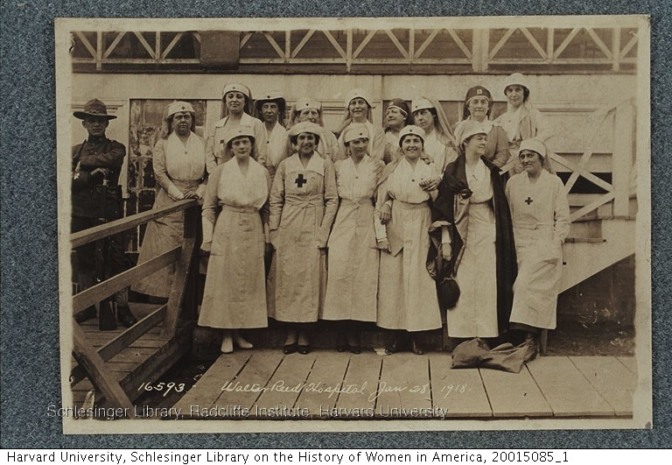](https://www.google.com/url?sa=i&rct=j&q=&esrc=s&source=images&cd=&cad=rja&uact=8&ved=0ahUKEwjT29ynpfTWAhUMPCYKHai0BjgQjRwIBw&url=http://guides.library.harvard.edu/schlesinger_WWI&psig=AOvVaw0uYFRh7wka82M4YfT5kTIq&ust=1508213870644314)

TECHNOLOGY AND INNOVATIONS

1. What is different that is in World War 1’s technology than had been in past wars?
2. What kind of advantages would this give the individuals using them?
3. Within the weaponry seen in the pictures, how do you think that warfare changed from the times of the Revolutionary and Boxer’s Rebellion?
4. What would all of these new advantages mean for later wars?

WARFARE IN THE TRENCHES

1. Describe how battles are being fought in these pictures.
2. What could be a problem with this type of warfare?
3. Why would soldiers dig trenches to stay in? And why do you believe they were in a zig zag pattern?
4. What are two advantages to being in a trench during war?

LIFE IN THE TRENCHES

1. What are some of the conditions you see in the trenches?
2. What problems do you for see for the soldiers living there?
3. How would dying in the trenches have a harmful effect on soldiers who were alive still in the trenches?
4. What problems would the conditions of the trenches have later on once soldiers returned home from war?

LIFE OF A SOLDIER IN WAR

1. Describe this man’s experiences.
2. What kind of jobs were the soldiers given during war time? And how were these jobs crucial?
3. What were some of the dangers of war?
4. How do you think these experiences would have an impact once soldiers came home?

NO MAN’S LAND

1. Why do you believe that this area of land was called No Man’s Land?
2. Why was barbed wire placed at all throughout No Man’s Land?
3. How do you think soldiers would cross this stretch of land?
4. How would No Man’s Land be an important factor in warfare during WW1?

AFRICAN AMERICANS DURING WW1

1. How is life different for African Americans in war that it is at home?
2. Why would African Americans be fighting in World War 1?
3. How do you believe life back home would change for African Americans?
4. How do you think that having segregated units would lead to the Harlem Renaissance?

HOSPITALS AND MEDICINE IN WORLD WAR 1

1. How were hospitals set up during WW1?
2. What could be some of the problems that the soldiers faced going into these wars?
3. How would women becoming involved in the war efforts lead to social changes both on the war front, as well as the home front?
4. How would injuries sustained in war that were unable to be treated on the battlefield hurt soldiers back home?